Use-Case Realization Report
Delete Outline

Issue <1.0>
Revision History
Date | Issue | Description | Author
12./10/09 | 1.0 | Initial Version | Rajendran Kumaraguru

Table of Contents
1. Brief Description 4
2. Flow of Events 4
2.1 Standard Flow 4
2.2 Exception Flow 4
3. Interaction Diagrams 4
3.1 Collaboration Diagram for Delete Outline 4
4. Participating Objects 5
5. Class Diagrams 5
5.1 Class Diagram for Delete Outline 5
6. Derived Requirements 5

Use-Case Realization Report
Delete Outline

Brief Description
Portal admin will be able to do the deletion of outlines which are already created for the particular company.

Flow of Events

Standard Flow
- Portal Admin login into the system.
- Portal admin clicks btnDelete_Click()
- Validate the fields before performing the deletion operation.
- Delete the outline
- Upon successful deletion then show the message to portal admin.

Exception Flow
  - If there is any validation error message then error message will be thrown to portal admin.
  - If there is no outline exist then respective message will be thrown to portal admin.

Interaction Diagrams

Collaboration Diagram for Delete Outline
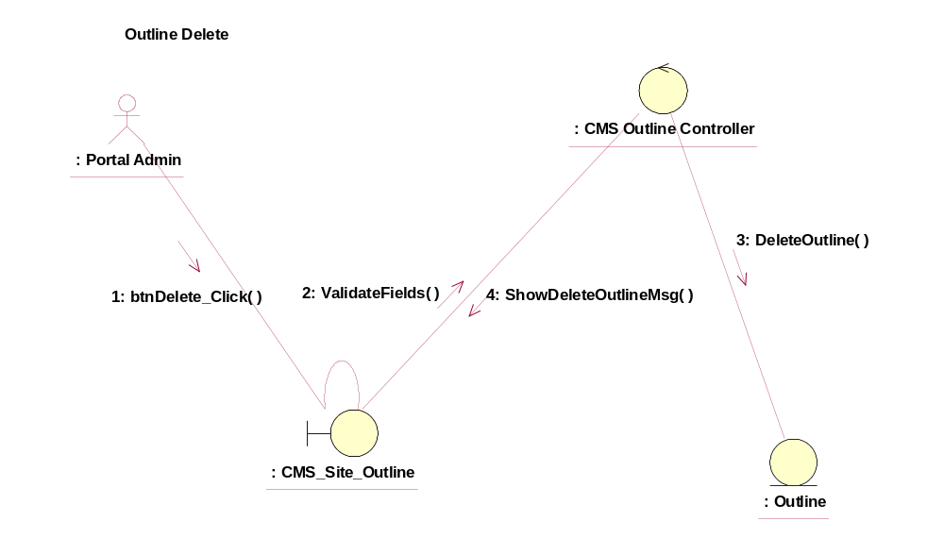

Participating Objects
CMS_Site_Outline
This object will be used for creating the outline.
: CMS Outline Controller
This is the controller to validate the files and duplicate check and creation of the outline..
: Outline
This is the object to store the outline info.

Class Diagrams

Class Diagram for Delete Outline
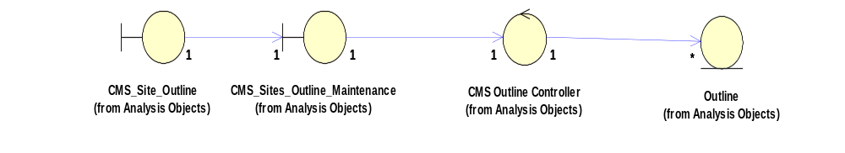

Derived Requirements
[enter the derived requirements here]

